Pensacola State College — Training and Conference Center
Campaign Leadership

Jan Miller, Chair
Dr. Ed Meadows, President

Cabinet Members

Vaughn Nichols
Jim Reeves
Sue Sue Sherrill
Ann Woll
Herb Woll

Today, there’s no space available for College or community conference or training needs when groups exceed 300 attendees for banquet or ballroom type events. The Jean & Paul Amos Studio can host up to 100 attendees in this type of setting. Requests from community partners of Escambia and Santa Rosa counties are routinely denied due to lack of available space at PSC campus and centers.

“When you have a multitude of blessings, you have a social responsibility to the community in which you live. I have tried to live a good life and contribute to my community.”

- Jan Miller, Campaign Chair and Donor

You Can Help

A dedicated Training and Conference Center would enable the College to enhance professional development training opportunities for faculty and staff. Additionally, students, community partners, and local nonprofits would benefit from the facility used to meet the various training, workshop, and conference needs detailed below:
- Business and Industry Training
- Corporate and Professional Development
- Seminars, Workshops, and Conferences
- Job Fairs for Local Employers to Meet Candidates for their Open Positions
- Nonprofit Center Workshops, Summit, and Trainings
- Hospitality and Culinary Student Engagement and Hands-On Experiences
- Internships and Mentorships, In-House Training
- Guest Lecturers to Share Expertise and Improve Student Experience
- Scholarship and Entrepreneurial Events to Promote Student Success
- Health Fairs for Students, Faculty, and Staff Members
- Reduced Event Expenses with Improved Opportunities and Availability
- Convenient Event Space for Community Nonprofits to Share their Mission
- Volunteer and Career Fairs to Invite Community Involvement
- Student and Employee Recognition Ceremonies

TODAY

The spaces available for use on campus have limited seating and are not conducive to large trainings, conferences, and events.

- WSRE Jean & Paul Amos Performance Studio — $1,250 cost just to move stage lighting
Capacity: 100 Seat Banquet Style, 499 Stadium Seats
- Delaino Student Center — Limited Availability with a Cost of Closure to Students
Capacity: 250 Seat Banquet Style
- Culinary Dining Room — Limited Availability due to Culinary and Hospitality Instructional Courses
Capacity: 60 Patrons

The closure and subsequent loss of frequently used community venues, such as New World Landing, burdens those seeking a conference or event setting.

Right now, there is a hole in the community that is being felt by Pensacola State College and community organizations.

“We’ve lost a home for our nonprofits, our job fairs, and professional trainings.”

- Trey Poirier, Foundation Board of Governors President

Naming Opportunities

Significant gifts to the College provide opportunities to designate the name of a facility or program in honor of donors. Rooms, or portions of them, are also included in these opportunities. Gifts designated to name a portion of this Training and Conference Center allow an individual to honor a namesake with a commitment to the enrichment of our community and its local resources. A naming opportunity is offered in recognition of a single, tax-deductible, irrevocable gift.

PENSACOLA CAMPUS
Conference and Training Center | NAMED
Training Suite A | $150,000
Training Suite B | $100,000
Training Suite C | $100,000
Sculpture Garden | $50,000
Lobby and Vestibule | $50,000
Outdoor Art for Placemaking | $25,000
Office/Ticket Sales | $10,000
Donor Wall Listing | $500 - $5,000

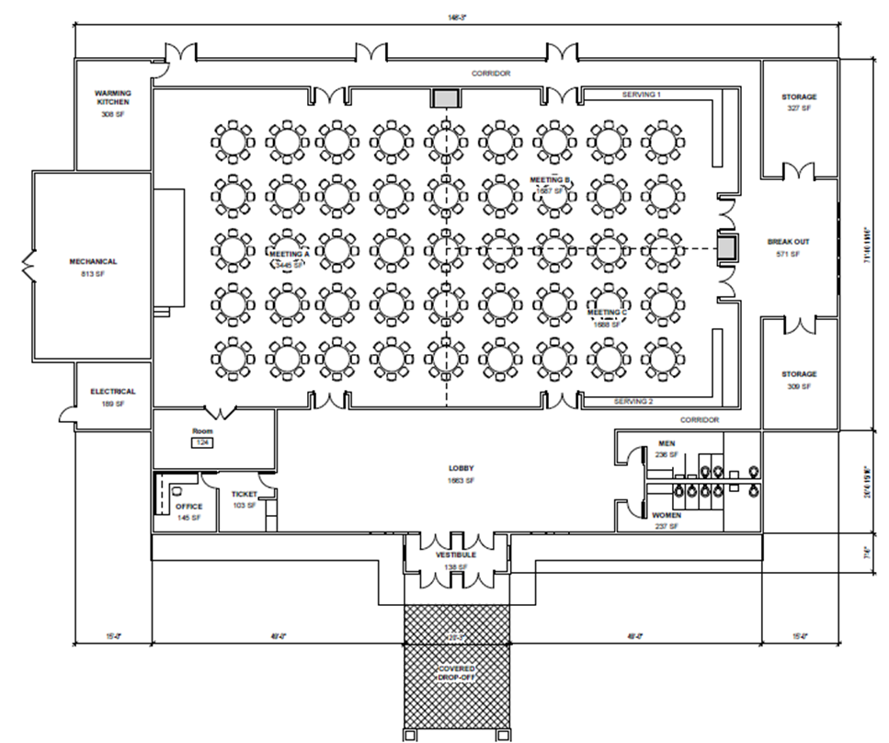

Room Usages and Capacities
Room | Mix & Mingle | Banquet | Classroom with Tables | Floor Row Seating | Career/Vendor Fair
Foyer | 50 – 60 | X | X | X | 4 – 6
Ballroom | 500 – 600 | 280 – 360 | 150 – 180 | 450 – 550 | 30 – 40
Meeting Room A | 300 – 350 | 120 – 175 | 75 – 125 | 250 – 300 | 15 – 20
Meeting Room B | 150 – 175 | 48 – 64 | 40 – 75 | 125 – 150 | 8 – 10
Meeting Room C | 150 – 175 | 48 – 64 | 40 – 75 | 125 – 150 | 8 – 10
Breakout Room | 25 – 30 | 10 – 12 | 10 – 12 | X | X

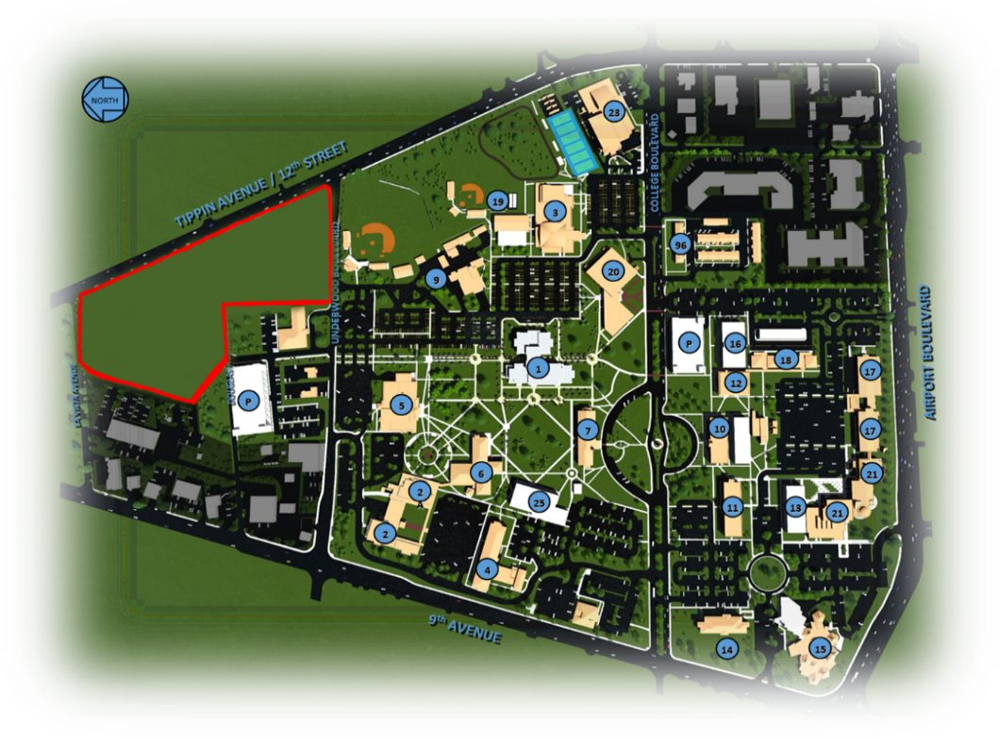
25 Acres Unimproved Property on 12th St.
“There are many special events, seminars, and workshops in the course of the academic year held at the campus by both the College and the community, yet we do not have a dedicated space for these events. We also have to decline requests or go off campus for our own events because the space we have is not large enough to accommodate special events. This facility would ensure that we do not inconvenience the regular activities of the campus when special events are requested.”

- Dr. Ed Meadows, Pensacola State College President

Donor Recognition Wall
Add your name to the Donor Recognition Wall for the Pensacola State College Training and Conference Center. This wall will be utilized to recognize the friends, foundations, organizations, and many individuals who have supported the Conference Center with significant financial contributions. Gifts of any size are gratefully accepted. Recognition begins at the $500 level. Each category on the wall signifies a level of contribution.
Legacy ($100,000 and up) Listing as a Legacy Donor
(Name, 60 characters on donor wall, cast bronze portrait plaque identifying named space)
Visionary ($50,000 - $99,999) Donor Wall as Visionary Donor
(Name, 50 characters on donor wall, cast bronze plaque identifying named space)
Leader ($25,000 - $49,999) Donor Wall as Leader
(Name, 45 characters on donor wall, cast bronze plaque identifying named space)
Sustainer ($10,000 - $24,999) Donor Wall as Sustainer
(Name, 35 characters on donor wall, cast bronze plaque identifying named space)
Benefactor ($5,000 - $9,999) Donor Wall as Benefactor
(Name, 35 characters on donor wall)
Champion ($2,500 - $4,999) Donor Wall as Champion
(Name, 35 characters on donor wall)
Supporter ($500 - $2,499) Donor Wall as Supporter
(Name)
Donor recognition is ongoing, and gifts may be made at any time as the wall will continue to grow with each qualifying gift. Plaques may be inscribed with the names of individuals or organizations making the gift and may be made in honor or memory of a loved one. All donations are tax-deductible. When we receive your pledge or check, we will send a form to detail the message on the donor wall and/or plaque.

