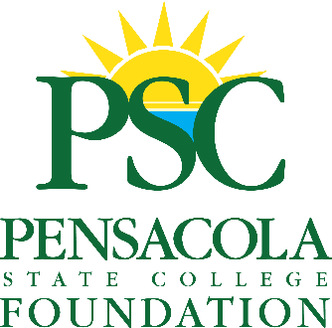

**2024 Day of Clays**

**Gun Raffle | Entry Form**

**Please Fill Out the Information Requested Below and Hand Deliver To:**

Pensacola State College Foundation:

1000 College Blvd. Building 17

Pensacola, FL 32504.

Name:________________________________________________________________

Address:______________________________________________________________

Phone: _______________________________________________________________

Email: ________________________________________________________________

OFFICIAL RULES: Requested ticket donation is $100 per ticket. A limit of 200 tickets will be sold. No purchase or contribution is necessary. Two Prizes will be drawn: A Benelli ETHOS Field 28” 20 Gauge Shotgun or A Beretta 686 Silver Pigeon 28” 12 Gauge Shotgun.

The winner will be determined by a random drawing at Santa Rosa Shooting Center on Saturday, October 5, 2024, at approximately 2 pm. The winner will be announced and notified by the end of the day on October 5, 2024. The odds of winning depend on the number of eligible entries received up to 200.

Only official entry forms are accepted. No duplicates, reproductions, or facsimiles are permitted. The winner must be a legal U.S. resident and have a driver’s license valid in the US. **Florida statute requires a completed background check before a Federal Firearm Licensee (FFL) may transfer a firearm to a non-licensed person**.

Pensacola State College and the Pensacola State College Foundation are not liable for the prize’s use, misuse, or non-use.

The Pensacola State College Foundation is a Non-Profit 501(c)(3) Organization

A COPY OF THE OFFICIAL REGISTRATION AND FINANCIAL INFORMATION MAY BE OBTAINED FROM THE DIVISION OF CONSUMER SERVICES BY CALLING TOLL-FREE WITHIN THE STATE, 1-800-435-7352, OR VISITING WW.800HELPFLA.COM. REGISTRATION DOES NOT IMPLY ENDORSEMENT, APPROVAL, OR RECOMMENDATION BY THE STATE.